Confidence interval for weighted regression

c+m*x-sqrt((t^2*d^2+t^2*e^2*x*((x-2*(x-f)))))

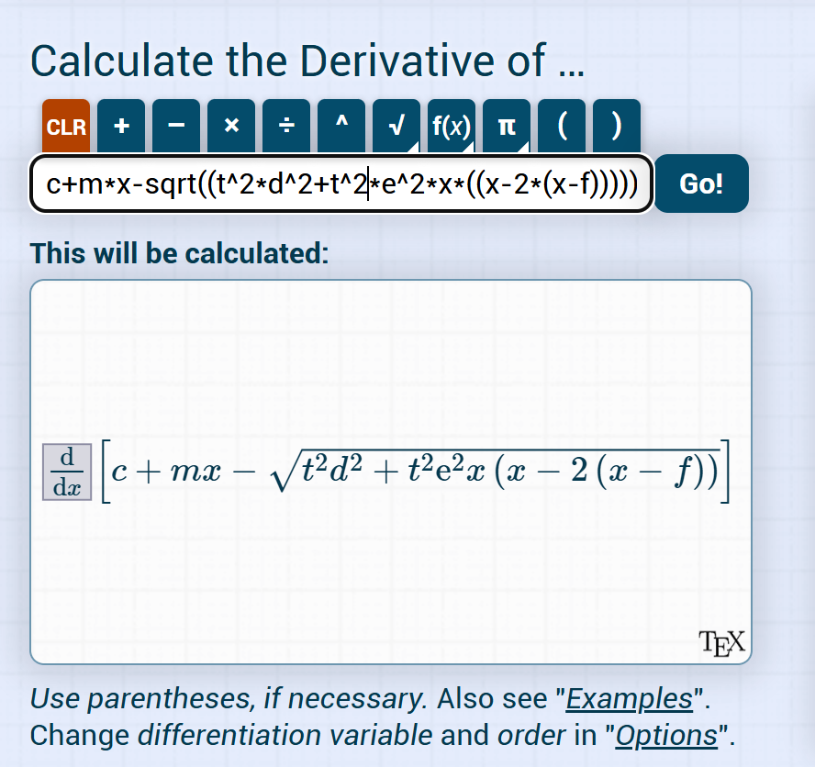
c is intercept
m is slope
d is intercept error
e is slope error
f is xcentroid

